Lab 03: Entity Relationship Diagram (Erd)
Consider a database system for an educational institute. Draw ERD Diagram on the given scenarios. The data requirements are summarized as follows:
Name: Muhammad Imran Butt
Reg No: L1F24BSCS0546
Section: D3
Task 1:
Business Case: Educational Institute
In an educational institute, there are several departments and students belong to one of them. Each department has a unique department number, a name, a location, phone number and is headed by a professor. Professors have a unique employee Id, name including first and last name and phone number. We like to keep track of the following details regarding students: name, unique roll number, gender, phone number, date of birth, age and one or more email addresses. Students have a local address consisting of the hostel name and the room number. They also have home address consisting of house number, street, city and PIN. It is assumed that all students reside in the hostels. A course taught in a semester of the year is called a section. There can be several sections of the same course in a semester; these are identified by the section number. Each section is taught by a different professor and has its own timings and a room to meet. Students enroll for several sections in a semester. Each course has a name, number of credits and the department that offers it. A course may have other courses as pre- requisites i.e, courses to be completed before it can be enrolled in. Professors also undertake research projects. These are sponsored by funding agencies and have a specific start date, end date and amount of money given. More than one professor can be involved in a project. Also a professor may be simultaneously working on several projects. A project has a unique projectId.Draw ERD to show entity, attributes and relations between these entities
Diagram:
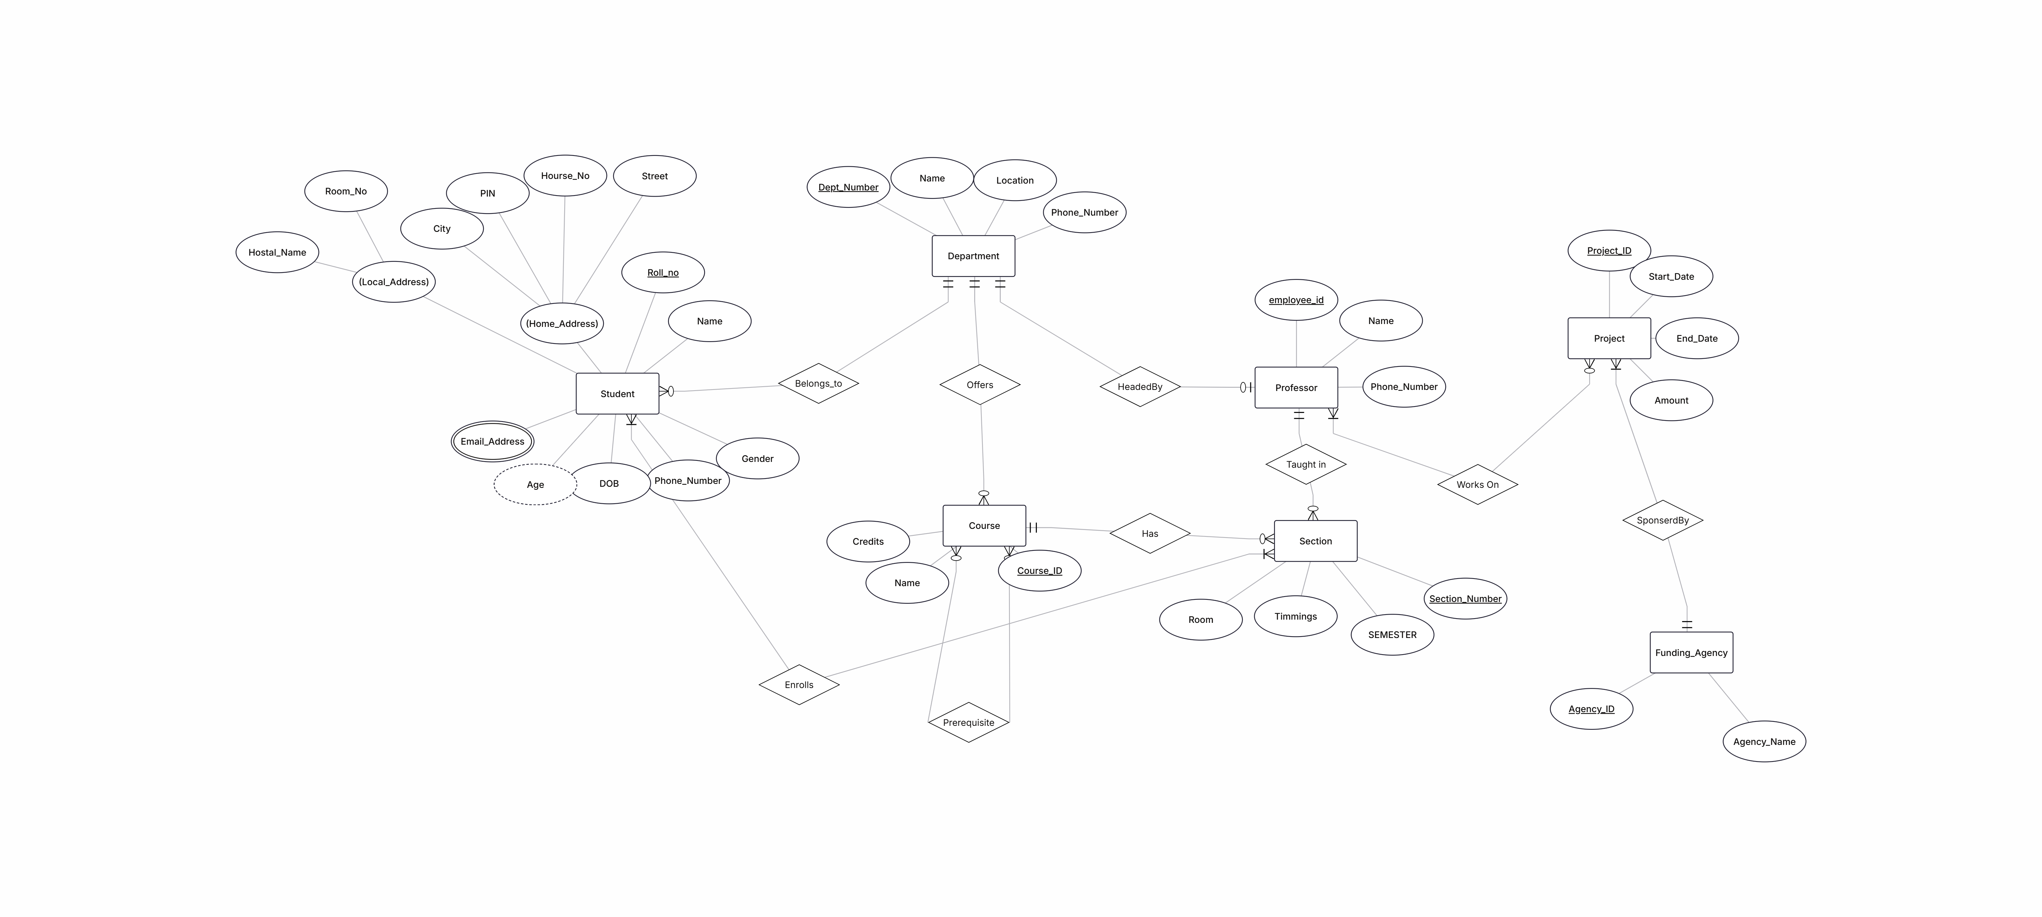
Task 2:
Business Case: Company Management system
Company has several departments. Each department may have several Locations. Departments are identified by a name, d_no, Location. A Manager control a particular department. Each department is associated with number of projects. Employees are identified by name, id, address, job, date_of_joining. An employee works in only one department but can work on several project. We also keep track of number of hours worked by an employee on a single project. Each employee has a dependent Dependent has D_name, Gender, and relationship.
Draw ERD on the above-mentioned scenario
Diagram:

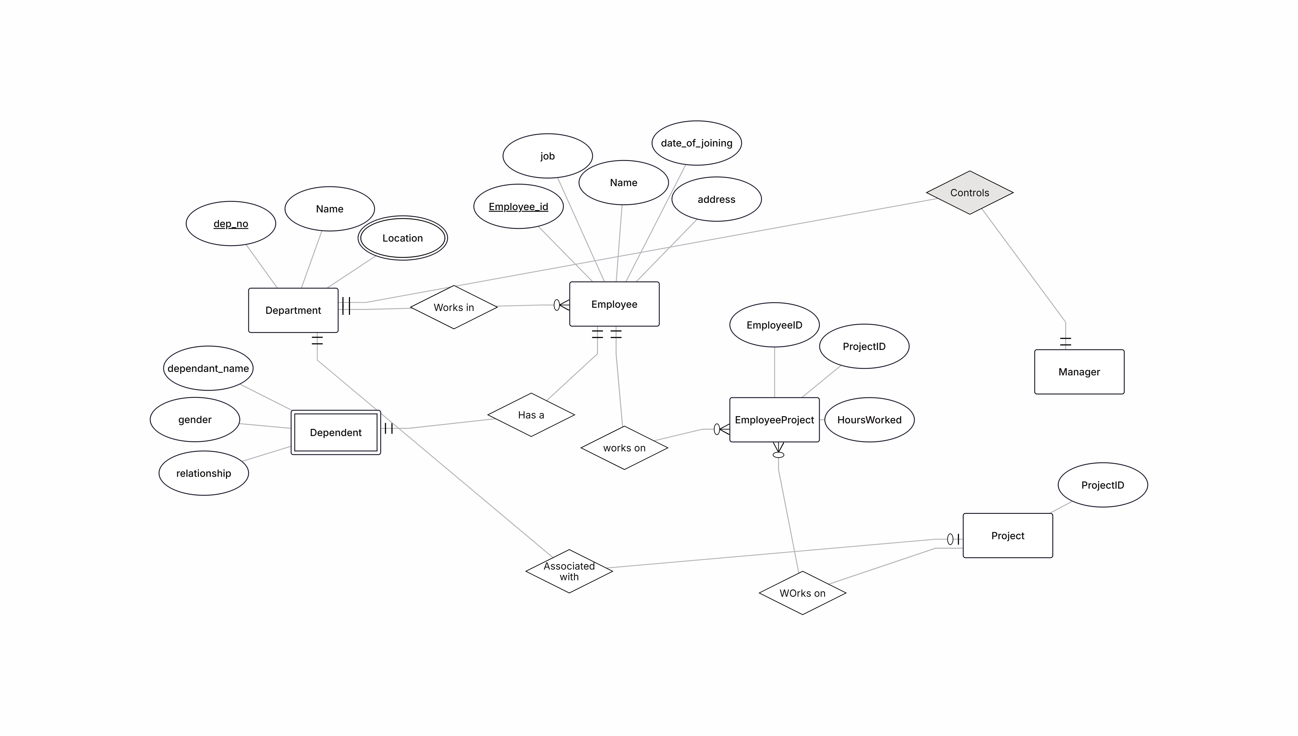

Task 3:
Business Case: Pak Wheels
Pak Wheels offers to its customers the option of purchasing a car using repayment schemes of over 1 year, 2 years, 3 years, 4 years or 5 years. A customer may purchase one or more cars under the scheme. When a customer purchases a car, he or she gets to choose one of the repayment scheme options for each purchase or may pay the whole amount in one go, meaning a repayment scheme option may be selected by one or more customers or may not be selected at all. A customer will have a unique customer number, a name, an address, and a phone number. A repayment scheme option will have a unique repayment scheme number, a name and the number of years for repayment. A car will have a unique car code, a make, a model, year of manufacture and a price. The company pays commission on sales of cars to its salespeople and therefore it will also keep information about each sale which will include a unique sales ID and commission to be paid on that sale. The company will also want to know who made the sales and the car involved in that transaction so that the commission can be determined. A salesperson will have a unique salesperson ID, a name, a phone number and an email address.
Draw ERD to show entity, attributes and relations between these entities.
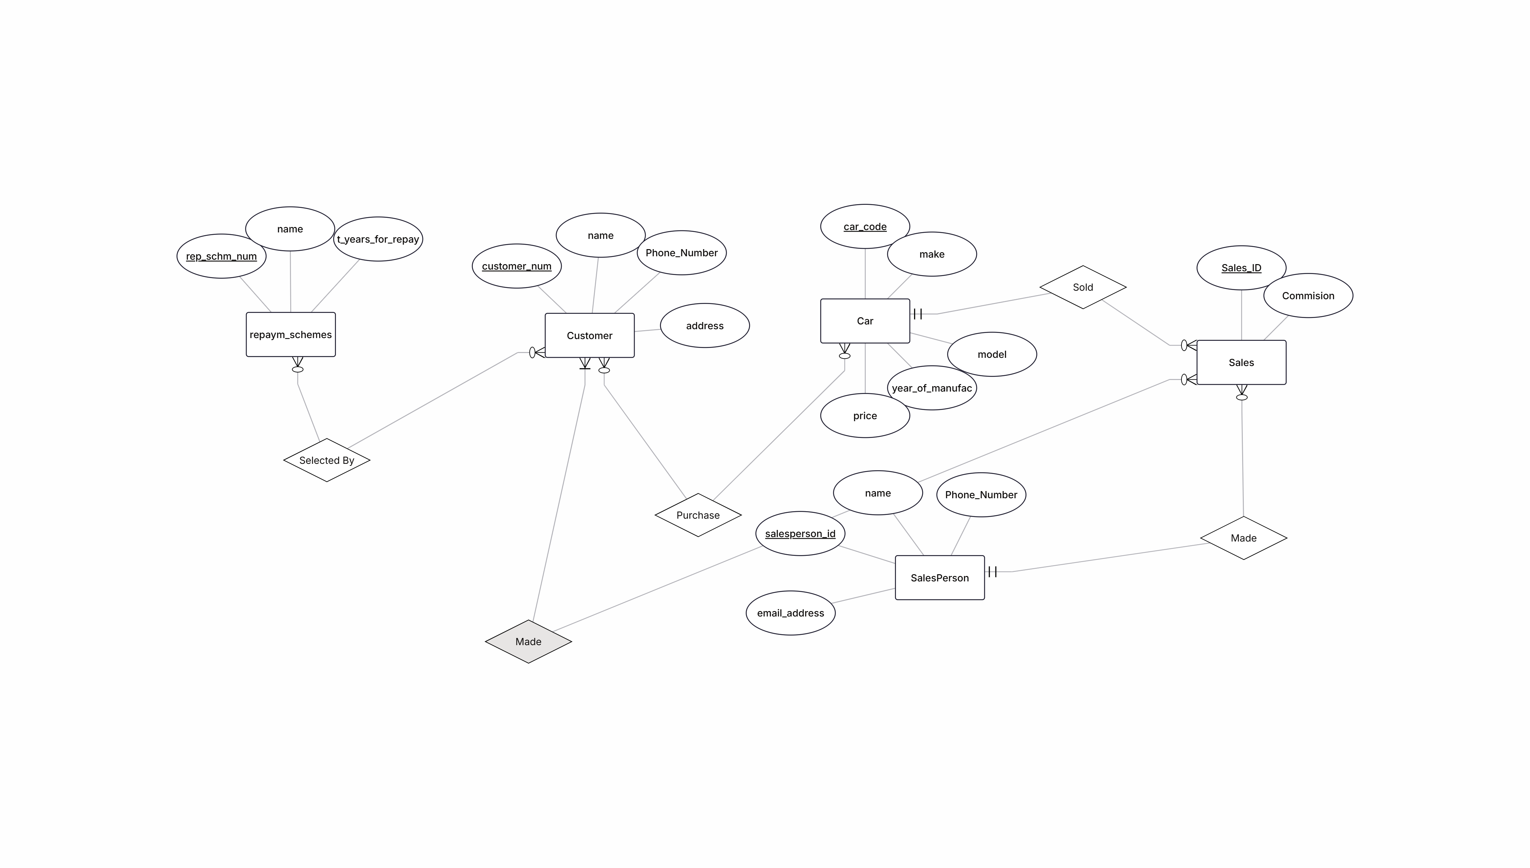

Task 4:
Business Case: Vaccination Center
Expo center Lahore is providing facilities of Vaccination in which they have vaccination staff, Citizen, Vaccination record and Halls. Vaccination staff has its own identity from ID, Name, qualification, Designation, Age and Salary. They also have Vaccination record in which they will maintain Vaccination number, Company name, Age group and quantity. Citizen who has CNIC, name, age, blood group, blood pressure, date of vaccination and vaccination number will be maintain in Citizen record. They are also maintaining record of each citizen in Citizen details in which they are maintaining CID, Citizen type (Doctor, Teacher, Disable or others), No of doses, Side effect (if any). There are 4 halls one for doctors one for teachers one for disable and one for others. On entry you will go to specific hall in which they will give you slip that may contain hall No, Citizen CNIC, Designation, Citizen type. Vaccination staff has many vaccinations and they are maintaining record of each vaccination. Each citizen is allowed only one vaccine at a time. Each hall has many citizens in which they are entry record of each citizen and give you slip in which your record is mentioned.
Draw ERD to show entity, attributes and relations between these entities.
Tool: Use online ERD Plus tool
Diagram:
